**Ansible Contd**

* Let’s try to install tomcat without using package manager
* <https://linuxize.com/post/how-to-install-tomcat-10-on-ubuntu-22-04/> for manual steps for installing tomcat 10 on ubuntu 22.04
* Installing java 11 on ubuntu <https://github.com/asquarezone/AnsibleZone/commit/0f1df0f46f3a49344cb57faa3dcff2831fd5efd0> for the changes done
* Add user and group create <https://github.com/asquarezone/AnsibleZone/commit/d803a27140c603501f688eabeceb70e57d06bd79> for the changes
* Downloading tomcat into temp directory <https://github.com/asquarezone/AnsibleZone/commit/2c0d8c9f0b6d18fbd5b85e09ba3593df50c31c9e> for changes
* <https://github.com/asquarezone/AnsibleZone/commit/19b5d732a1eac8317c3d77752d29a622e08bdeec> for the changes to extract tomcat
* <https://github.com/asquarezone/AnsibleZone/commit/81f508ede87764528d4550e44e32bc9c74f17726> for the symlink changes
* <https://github.com/asquarezone/AnsibleZone/commit/e1db13483d0296ba3f311996bb6f726c0bb7af19> for changes to change home directory ownership
* Let’s directly run the linux command form ansible. This is not idempotent <https://github.com/asquarezone/AnsibleZone/commit/0a0ad9c93684f5c6633f7dcf72e3b723feebc2cc>
* We need to create a service file but it has dynamic content, so copying static file is not an option, Ansible has templating
  + for expressions we use jinja templates <https://docs.ansible.com/ansible/latest/playbook_guide/playbooks_templating.html>
  + for module we use template module <https://docs.ansible.com/ansible/latest/collections/ansible/builtin/template_module.html>
* <https://github.com/asquarezone/AnsibleZone/commit/9b7ae9d4351e0ede852436ec3a1570b2094813b3> for the changes to use template. This should bring up the tomcat server  
  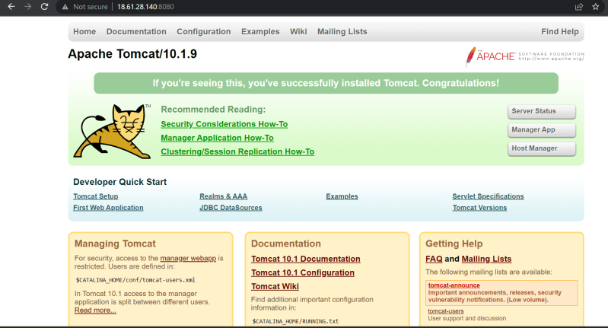
* As of now when we run our playbook 3 tasks are getting executed every time and this needs to be fixed  
  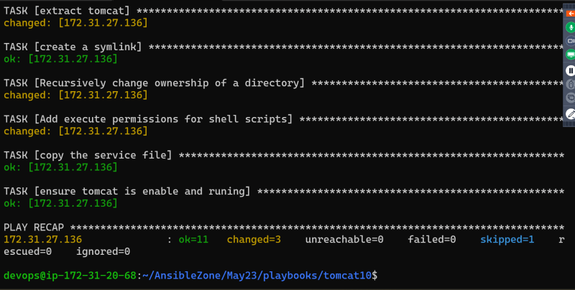
* <https://github.com/asquarezone/AnsibleZone/commit/6c8ca3553d5877c6d47c4f4b810b49f1761b2d79> for the fix of the above problem
* <https://github.com/asquarezone/AnsibleZone/commit/dec9bb66635ba0a1823f98403de2e17fa38e8b9e> for the steps to configure tomcat management interface
* As of now we have written the playbook which works on ubuntu and installs tomcat
* Tags in Ansible <https://docs.ansible.com/ansible/latest/playbook_guide/playbooks_tags.html>